Project: Predictive Analytics Capstone

Using Alteryx 2021.3

## Task 1: Determine Store Formats for Existing Stores

1. **What is the optimal number of store formats? How did you arrive at that number?**

Optimum number of store formats is 3.

The project explicitly states to use K-Mean clustering only, so the other models, K-Median and Neural Gas, were not evaluated. The number of clusters explored ranged from 2 to 8 and for each number of clusters, their Adjusted Rand (AR) Indices and Calinski-Harabasz (CH) Indices were evaluated.

While the number of clusters of 2 may seem to be an appropriate number based on the highest AR and CH indices, the high number of outliers (open circles) at the lower fence of the box plot for the CH index for cluster 2 may indicate high probability for deviations if this number of clusters is chosen. Instead, a safer choice is the next best that is 3 clusters.

Note: the version of Alteryx and random seeds used can affect the clustering results.

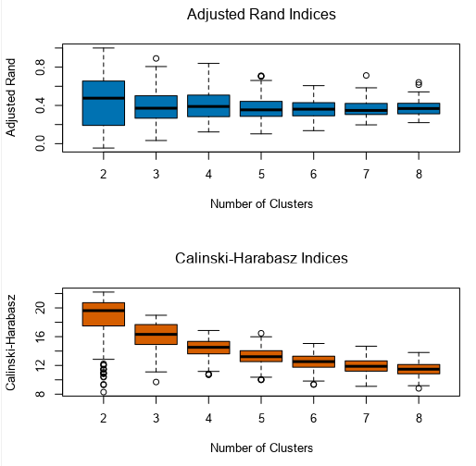

1. **How many stores fall into each store format?**

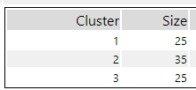

1. **Based on the results of the clustering model, what is one way that the clusters differ from one another?**

From the principal component relationships between component 1 and 2 in the figure below, there is a similar co-relationship for PC1 and PC2 in Store Format 1 for Meat and Deli. Also, the median percent for Meat and Deli are higher than for the other 2 Store Formats by about 0.9 and 0.7 basis points respectively

For Store Format 2, Floral, Produce and Dairy are the strong sellers and their median percent sales are higher than the other 2 by 0.2, 2.0 and 0.5 basis points respectively.

For Store Format 3, General Merchandise are the top seller and their median percent sale are higher than the other by 2.0 basis points.

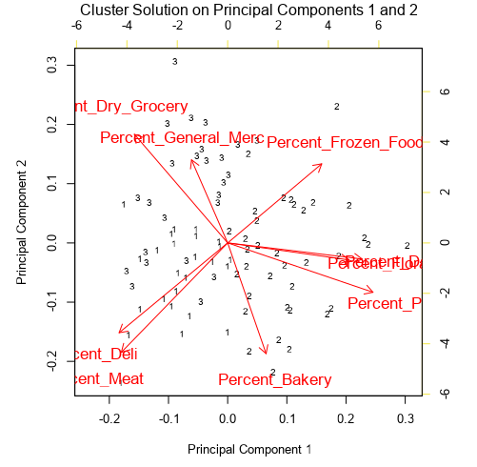

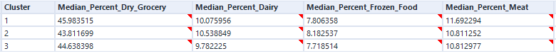



1. Please provide a Tableau visualization (saved as a Tableau Public file) that shows the location of the stores, uses color to show cluster, and size to show total sales.

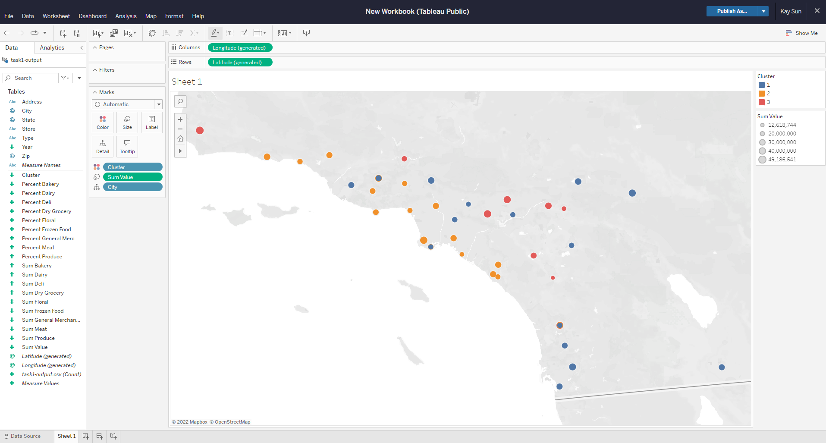

## Task 2: Formats for New Stores

1. **What methodology did you use to predict the best store format for the new stores? Why did you choose that methodology? (Remember to Use a 20% validation sample with Random Seed = 3 to test differences in models.)**

Boosted model is selected to predict the best store format for the new stores.

Store demographics and clustering out from Task1 were joined by Store and the resulting dataset split into 80% training and 20% validation. The training dataset was used to train the Decision Tree, Random Forest and Boosted models using on the demographics data (double datatype) to predict the Cluster target variable (categorical datatype). The performance of each model was compared. Of the 3 models, the Decision Tree model performed worst with lowest Accuracy and F1 scores, while both the Random Forest and Boosted models performed best and equally based on Accuracy, F1 scores and Confusion Matrix. The equal performances of the 2 models is probably due to the low sample size of the dataset (85 training and 10 validation).

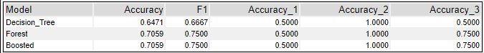

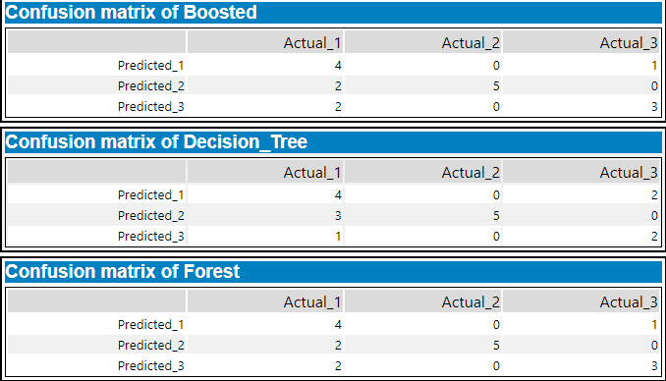

1. **What format do each of the 10 new stores fall into? Please fill in the table below.**

|  |  |
| --- | --- |
| Store Number | Segment |
| S0086 | 1 |
| S0087 | 2 |
| S0088 | 3 |
| S0089 | 2 |
| S0090 | 2 |
| S0091 | 3 |
| S0092 | 2 |
| S0093 | 3 |
| S0094 | 2 |
| S0095 | 2 |

## Task 3: Predicting Produce Sales

**1. What type of ETS or ARIMA model did you use for each forecast? Use ETS(a,m,n) or ARIMA(ar, i, ma) notation. How did you come to that decision?**

ETS(M, N, M) was selected to forecast for the 3 Store Formats.

ETS and ARIMA models for the 3 Store Formats were compared using the last 6 months of data that had been held out. The ETS model for each Store Front cluster consistently perform better than corresponding ARIMA with smaller error metrics including ME, RMSE, MAE, MPE, MAPE and MASE. The plots pf actual vs forecast values for the 3 Store Fronts also showed closer predictions for ETS than ARIMA models.

Store Format 1:

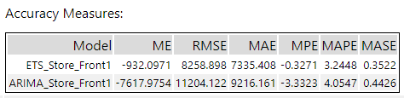

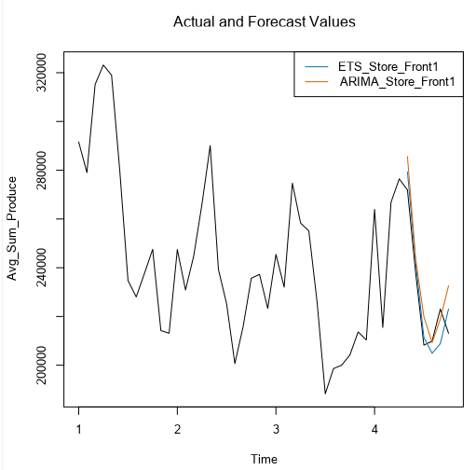

Store Format 2:

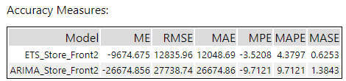

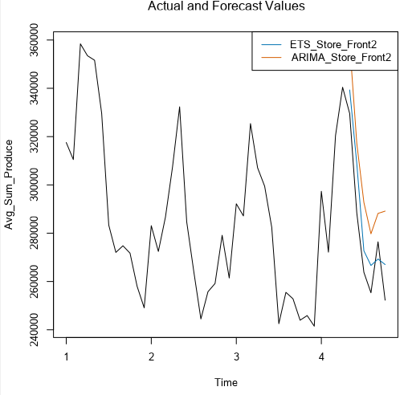

Store Format 3:

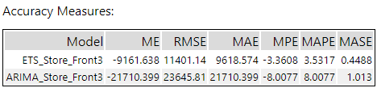

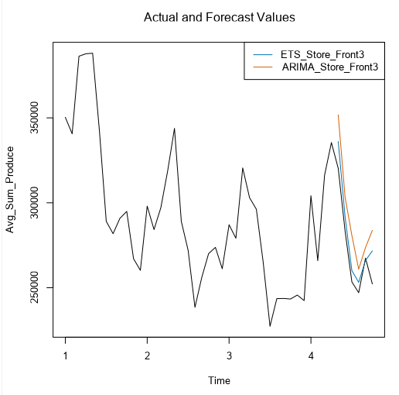

Decomposition plots of Store Format 1 cluster showed growing error, no trend and slight increasing seasonality for M, N and M notation.

Store Format 1:

|  |  |
| --- | --- |
|  |  |

Decomposition plots of Store Format 2 cluster also showed growing error, no trend and slight increasing seasonality for M, N and M notation.

Store Format 2:

|  |  |
| --- | --- |
|  |  |

Likewise decomposition plots of Store Format 3 cluster showed growing error, no trend and slight increasing seasonality for M, N and M notation.

Store Format 3:

|  |  |
| --- | --- |
|  |  |

**2. Please provide a table of your forecasts for existing and new stores. Also, provide visualization of your forecasts that includes historical data, existing stores forecasts, and new stores forecasts.**

Forecast models for each Store Front predicts the average produce sales monthly in 2016. Multiplying each with the total number of existing stores in each Store Front cluster and summing monthly gives the monthly forecasts for the 85 existing stores.

Repeating the calculation for the new stores (1 in Store Front 1, 6 in Store Front 2, 3 in Store Front 3) results in monthly forecasts for the 10 new stores.

Table below shows the forecasts of produce sales from the 10 new stores and 85 existing stores for each month in 2016.

|  |  |  |
| --- | --- | --- |
| **Month** | **New Stores** | **Existing Stores** |
| Jan-16 | $ 2,910,944.15 | $ 24,078,058.16 |
| Feb-16 | $ 2,764,881.87 | $ 22,670,735.53 |
| Mar-16 | $ 3,141,305.87 | $ 25,858,187.53 |
| Apr-16 | $ 3,195,054.20 | $ 26,288,436.90 |
| May-16 | $ 3,212,390.95 | $ 26,501,400.91 |
| Jun-16 | $ 2,852,385.77 | $ 23,303,548.46 |
| Jul-16 | $ 2,521,697.19 | $ 20,583,812.16 |
| Aug-16 | $ 2,466,750.89 | $ 20,160,031.58 |
| Sep-16 | $ 2,557,744.59 | $ 20,888,455.26 |
| Oct-16 | $ 2,530,510.81 | $ 20,891,395.24 |
| Nov-16 | $ 2,563,357.91 | $ 21,057,160.62 |
| Dec-16 | $ 2,483,924.73 | $ 20,415,891.84 |

Figure below illustrates the forecasts of produce sales from the new stores and existing stores for each month in 2016. Given there are 10 new stores compared to 85 existing stores, the forecasted produce sales for new stores are much less than that of the 85 existing stores.

